Template for Preparing a Paper for Resilient2025 (APA style)[1]#

Author A1, Author B 2*

1 Affiliation of author A

2 Affiliation of author B

(Corresponding Author: Email)

Abstract

Resilient2025 is organized by the international journal, Applied Energy, Advances in Applied Energy, Applied Energy Innovation Institute (AEii) and Mälardalen University, Sweden. The event consists of three-day symposium in Västerås (SEP 23-25) for sharing the most recent progress of research R&Ds in resilient energy systems.

**Keywords:** renewable energy resources, advanced energy technologies, mitigation technologies, intelligent energy, energy systems, climate change (Max. 6)

Nonmenclature

|  |  |
| --- | --- |
| *Abbreviations* |  |
| ADAPEN | Advances in Applied Energy |
| *Symbols* |  |
| n | Year |

1. Introduction

Welcome to Resilient-Applied Energy Symposium and Forum: Resilient energy systems. Water and food supply, transportation, health, internet, communication channels, industry, and other sectors essentially depend on energy. Without energy, no infrastructures and sectors can be operated. Hence, the energy sector is today’s most critical infrastructure. A failure in parts of the energy sector results in negative impact on other infrastructure systems – and may result in situations of disaster. The transition towards a more electrified, decentralized and digitalized energy system with high share of renewables brings many challenges but also opportunities.

The transformation to resilient energy systems is dependent on interdisciplinary knowledge. With this as theme of the conference, the Resilient2025 aims to provide a premier international forum for all stakeholders including academia, industry and policy decision makers to present and share latest findings in all aspects across this domain, discussing issues such as security of supply, flexibility solutions, sector coupling as well as market developments at local, regional, national and international level to support a more sustainable and resilient energy system.

1. REQUIREMENTS OF PAPER STRUCTURE
   1. Subdivision - numbered sections

Fig. 1 Small diagram

A paper submitted to Resilient2025/Energy Proceedings should not exceed 6 pages. Please use this template to prepare your paper. Please use this template to prepare your paper. **Font Calibri** should be used with the size of 11. Figures and tables should be embedded and not supplied separately. Please strictly follow all format requirements such as the page margins, authors, affiliations, headings, captions of tables and figures, references etc.

Divide your article into clearly defined and numbered sections. Subsections should be numbered 1.1 (then 1.1.1, 1.1.2, ...), 1.2, etc. (the abstract is not included in section numbering). Use this numbering also for internal cross-referencing: do not just refer to 'the text'. Any subsection may be given a brief heading. Each heading should appear on its own separate line.

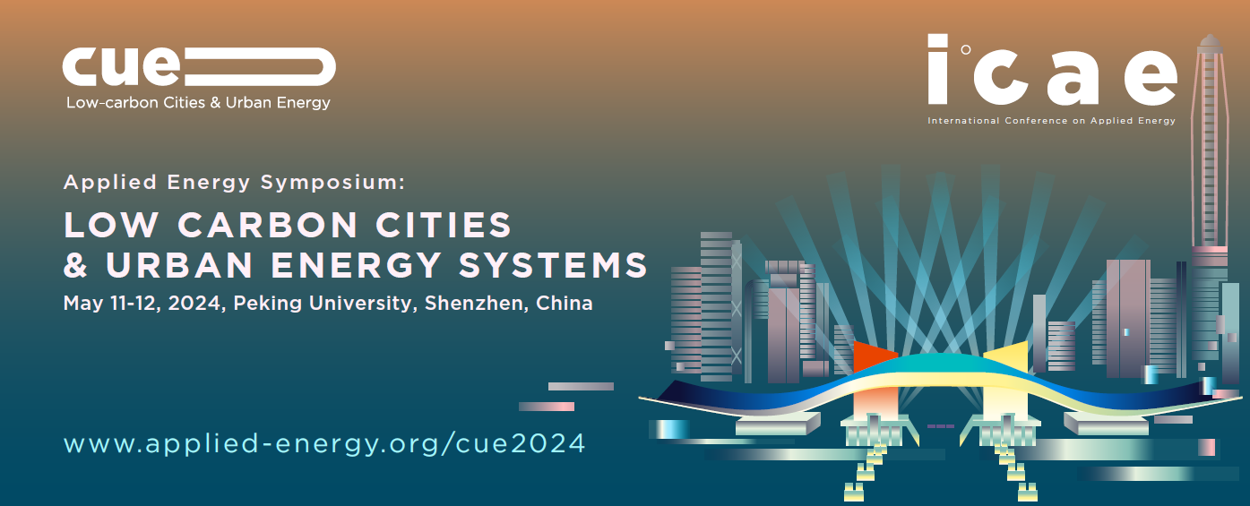

Fig. 2 Large diagram

* 1. Section of Introduction

State the objectives of the work and provide an adequate background, avoiding a detailed literature survey or a summary of the results.

* 1. Section of material and methods

Provide sufficient detail to allow the work to be reproduced. Methods already published should be indicated by a reference: only relevant modifications should be described.

* 1. Section of theory/calculation

A Theory section should extend, not repeat, the background to the article already dealt with in the Introduction and lay the foundation for further work. In contrast, a Calculation section represents a practical development from a theoretical basis.

* 1. Section of results

Results should be clear and concise.

* 1. Section of discussion

This should explore the significance of the results of the work, not repeat them. A combined Results and Discussion section is often appropriate. Avoid extensive citations and discussion of published literature.

* 1. Section of conclusions

The main conclusions of the study may be presented in a short Conclusions section, which may stand alone or form a subsection of a Discussion or Results and Discussion section.

* 1. Section of references

### 2.8.1 Citation in text

Any references cited in the abstract must be given in full. Unpublished results and personal communications are not recommended in the reference list, but may be mentioned in the text. If these references are included in the reference list, they should follow the standard reference style of the journal and should include a substitution of the publication date with either 'Unpublished results' or 'Personal communication' Citation of a reference as 'in press' implies that the item has been accepted for publication.

### 2.8.2 Web references

As a minimum, the full URL should be given and the date when the reference was last accessed. Any further information, if known (DOI, author names, dates, reference to a source publication, etc.), should also be given. Web references can be listed separately (e.g., after the reference list) under a different heading if desired.

1. material and methods

Xxx …….

1. results

Xxx …….

1. discussion

Xxx …….

1. Conclusions

Xxx …….

Acknowledgement

xxx xxx xxx

Reference

[1] Van der Geer J, Hanraads JAJ, Lupton RA. The art of writing a scientific article. J Sci Commun 2010;163:51–9. (Reference to a journal publication)

[2] Strunk Jr W, White EB. The elements of style. 4th ed. New York: Longman; 2000. (Reference to a book)

[3] Mettam GR, Adams LB. How to prepare an electronic version of your article. In: Jones BS, Smith RZ, editors. Introduction to the electronic age, New York: E-Publishing Inc; 2009, p. 281–304. (Reference to a chapter in an edited book)

[4] Mitchell, J.A., Thomson, M., & Coyne, R.P. (2017, January 25) APA citation. *How and when to reference*. Retrieved from <https://www.howandwhentoreference.com/APAcitation>

1. # This is a paper for the Resilient-Applied Energy Symposium and Forum: Resilient energy systems (Resilient2025), Sep. 23-25, 2025, Västerås, Sweden.